SETTING UP AN ENVIRONMENT

IBM Cloud Account

|  |  |
| --- | --- |
| Date | 04 November 2022 |
| Team ID | PNT2022TMID16501 |
| Project Name | Plasma Donor Application |
| Maximum marks |  |

**Step 1:** Type or click the below link in the browser ***https://***[***www.ibm.com/academic/home***](http://www.ibm.com/academic/home)

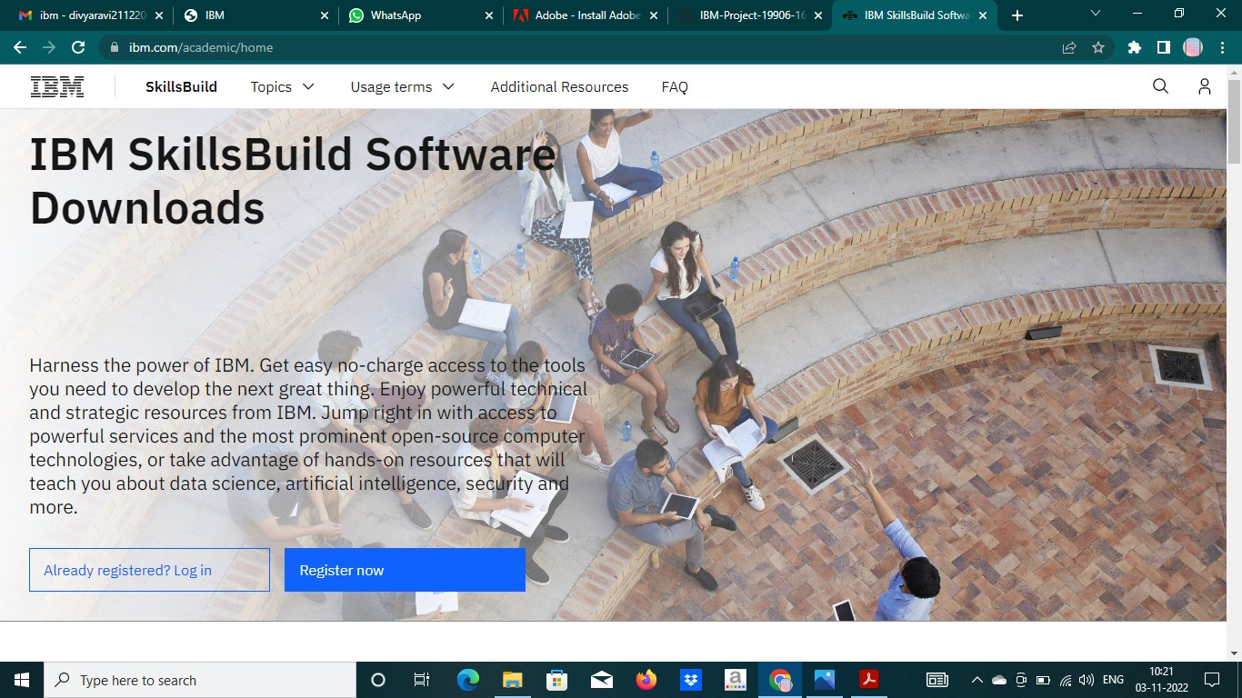**Step 2:** Click register icon and give all the details one by one,

**Step 3:** Already you got SI EMAIL and SI PASSWORD from your IBM student login. Login to your web mail account. Wait for 7-digit verification code in your web mail: ***https://sg2plmcpnl496936.prod.sin2.secureserver.net:2096/***

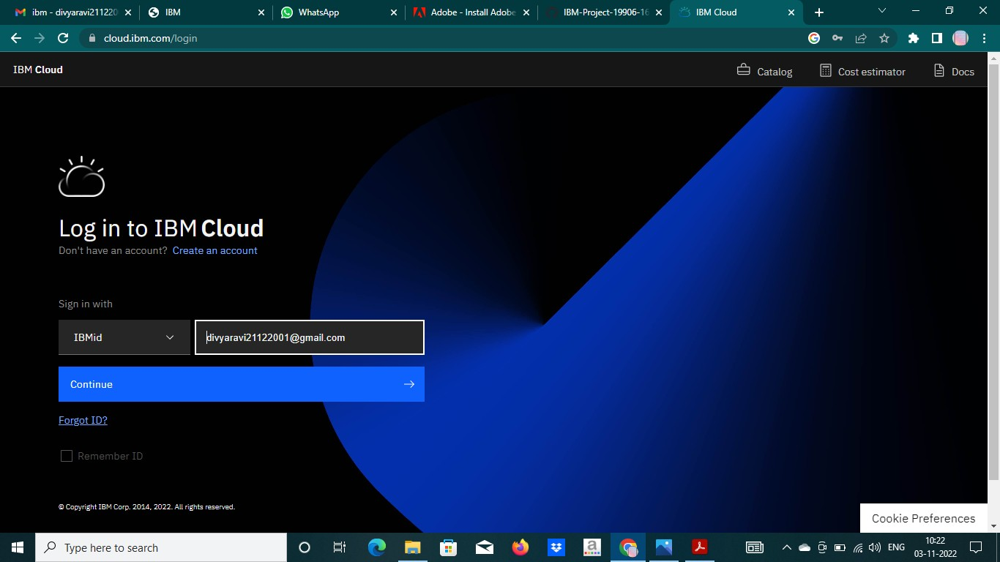

**Step 4:** Get 7-digit verification code in webmail, then go to registration page and enter the verification code.

**Step 5:** Now, you have successfully created the IBM Cloud Account.

**Step 6**: Go to IBM Cloud login page: ***https: //cloud.ibm.com/login*** ,then enter your IBM Id and Password.

**Step 7:** Finally, you will access the IBM cloud account

